1. Write a program using WHILE statement that displays a right triangle using asterisks where the height is at the left corner of the application. The height will depend on the user input.

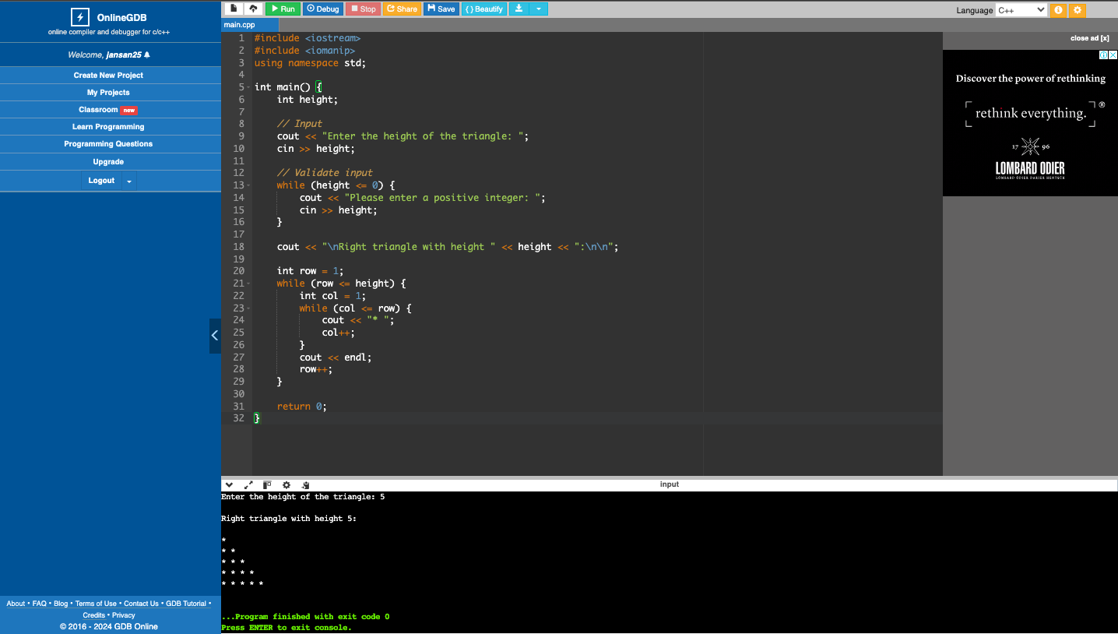

1. Write a program using FOR statement that displays a right triangle using asterisks where the height is at the right corner of the application. The height will depend on the user input.

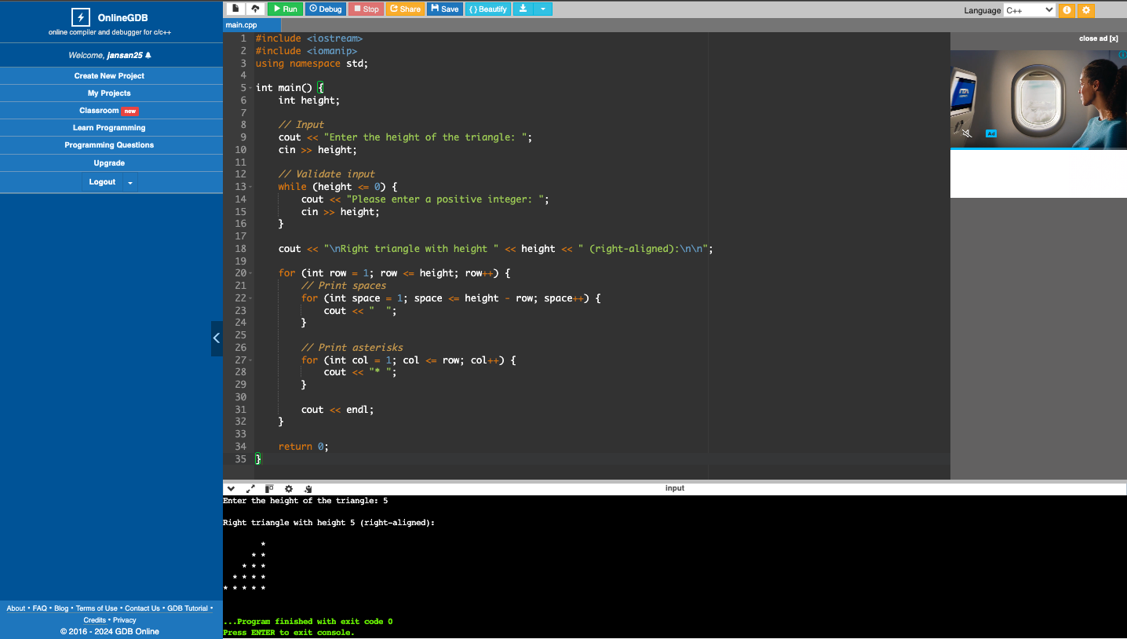

1. Write a program using DO WHILE statement that displays an inverted equilateral triangle using asterisks. No asterisk should be adjacent to one another. The height will depend on the user input.

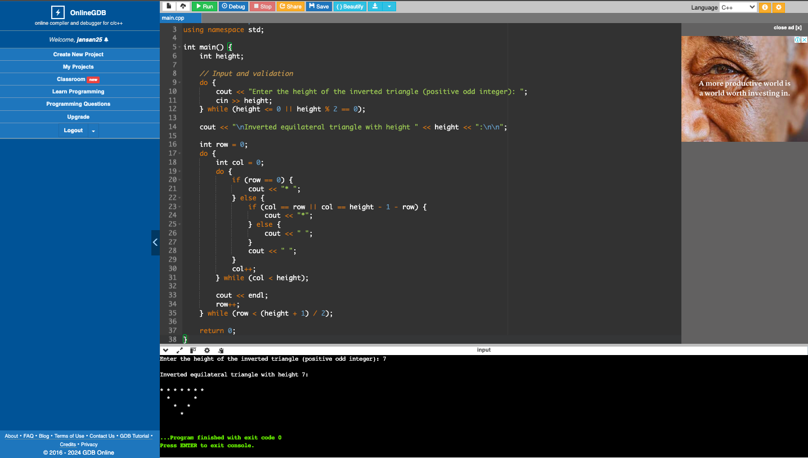

1. What can you conclude from this activity?

Effective implementation of loops reduces repetitive tasks for users and streamlines code by minimizing redundant procedures. This approach not only automates repetitive actions but also results in more concise programming, ultimately reducing the overall amount of code required.